LECTURE SYLLABUS
(General medicine, dental medicine)

Fever

Poikilothermic organisms
Homoiothermic organisms

Normal temperature if measured in the axilla: 35.8 – 37.0 °C
(rectal temperature about 0.5 °C higher)
Day oscillations: the lowest at 4:00 a.m., the highest late afternoon
Hormones increasing body temperature:
Progesterone, T-hormones, STH, testosterone, adrenalin, noradrenalin
The influence of activity, environment…

Body temperature control
Center: hypothalamus
Thermoreceptors:
hypothalamus, peripheral receptors (spinal cord, abdominal cavity, large veins)
→ vegetative system → reaction of tissues and organs
→ behavior
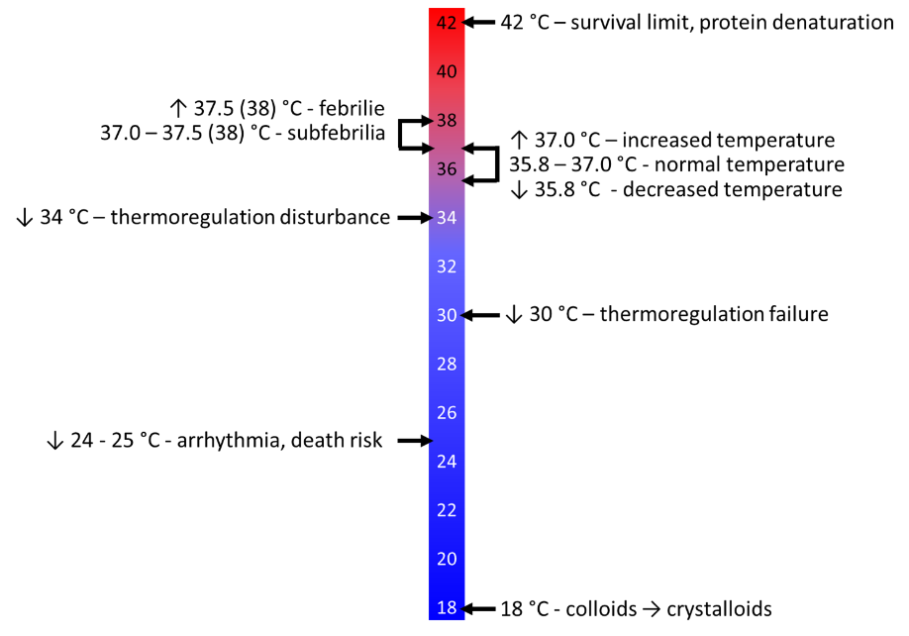

Fever = febris
Symptom of a disease

Pyrogens: bacterial endotoxins, viruses, aseptic tissue damage…
Activation of macrophages → production of cytokines (endogenous pyrogens) IL-1β, IL-6, TNF-α
→ production of prostaglandins (PGE₂) → hypothalamus programmed to maintain higher temperature → processes increasing body temperature
Prostaglandin production – cyclooxygenase
Fever does not need occur in old people and in the case of hypothalamus damage.

Fever stadia:
1) incrementi – cold feeling, temperature increase, shivering (thermogenesis)
2) akme - temperature corresponds with the hypothalamus setting
- cold feeling and shivering disappear
3) decrementi - after provoking factor disappears
→ normalization of the hypothalamus setting
→ processes leading to temperature decrease
- quickly = crisis
- slowly = lysis
Fever types
- Febris continua = changes of the temperature within one day < 1 °C
- Febris remittens = temperature changes within one day > 1 °C
- Febris intermitens = period of fewer and of normal temperature

Fever importance
- ↑ leukocyte generation
- Acceleration of leukocyte migration
- ↑ antibody production
- Inhibition of microbe growth

Effects on the organism
- Increase of basal metabolism, catabolic processes
- Cardiovascular system - ↑ heart rate (1 °C ~ 10 beats/min)
- Respiration - tachypnoea
- CNS - inhibition (somnolence, apathy) or excitation (insomnia, unrest, hallucination), headache
- GIT - ↓ secretion
- ↑ water resorption
- Kidneys - decreased urine production
→ cardiovascular system overload
→ energy source reduction
→ dehydration
→ protein denaturation when > 42 °C
→ febrile seizures in newborns

Febrile seizures = convulsiones febriles
The most common cause of cramps in children (2-5 % of children < 5 years)
Tonic-clonic cramps, potentially unconsciousness
- Non-complicated febrile seizures
- disappear within 3 min (max. 15 min)
- good prognosis
- Complicated febrile seizures - > 15 min, recidive within 24 h
- Febrile epileptic state - > 30 min
Unclear etiopathogenesis
Temperature > 38 °C

