LECTURE SYLLABUS
(General medicine, dental medicine)

Pathophysiology of tumors

Tumor (neoplasm) = structure developing by uncontrolled proliferation of abnormal cells
Also diffuse tumors - leukemia

- Loss of cell cycle control → autonomous proliferation
- Disorder of cell differentiation
- Tumor phenotype of the cells

Tumor-like structures, pseudotumors
- dif. dg.

- Hypertrophy, hyperplasia
- Pathological compound deposition
- Inflammatory pseudotumors - edema, cell proliferation
- Schloffer's tumor - inflammatory origin, around a foreign particle (e.g. surgical stitches)
- Hamartia - tissue segment not integrated into the organ structure
- Parasites - tapeworms (cestoda) - Echinococcus, Alveococcus
- Cyst
- Pseudocyst

Tumor classification

According to biologic features
- benign
- intermediary
- malignant

According to histogenesis
- epithelial
- mesenchymal
- from neural tissue
- mixed
- teratoma
- trophoblast-derived tumors

Typing
Grading
Staging

Benign tumors
Slow growth
Quite good differentiation
Delimited, often encapsulated
Expansive growth = volume increase, compression of surrounding tissue, but no infiltration
No metastases
→ Easy surgical ablation of the whole tumor = no tumor recurrence

Problematic localizations and features:
- Intracranial localization
- Endocrine activity
- Organ compression, duct obstruction, gut obstruction
- Risk of malignisation

Malignant tumors
- Rapid growth
- Cellular and nuclear irregularities, frequent mitoses
- No delimitation
- Infiltrative (invasive) and destructive growth = increase their volume and invade the surrounding tissue
- Metastases
→ Difficult complete surgical ablation of the whole tumor = surgery does not always mean complete healing

But:
E.g. the basalioma does not create metastases → benign from the clinical point of view

Metastases
= secondary tumor
A piece of tumor tissue, tumor cell, cell cluster separates from the primary tumor and moves to another place, where it is implanted and gives origin to a secondary tumor.
→ affection of more organs, enlargement of total tumor mass, source of disease recidive after surgical ablation of the primary tumor

Ways of metastatic process:
- hematogenic
- lymphogenic
- porogenic
- per continuitatem - e.g. prostate cancer spreads into the urinary bladder

Tumor development
- Clonal theory - a tumor originates from one transformed cell
- Mutation (somatic) - tumor initiation
→ tumor transformation of the cell - complex change of cell phenotype:
- ↑ proliferation ability
- ↓ or abnormal differentiation
- ↓ apoptosis
- telomerase activity
- changed interaction with cells and extracellular matrix
Tumorigenesis is a process having several steps, more mutations are needed.

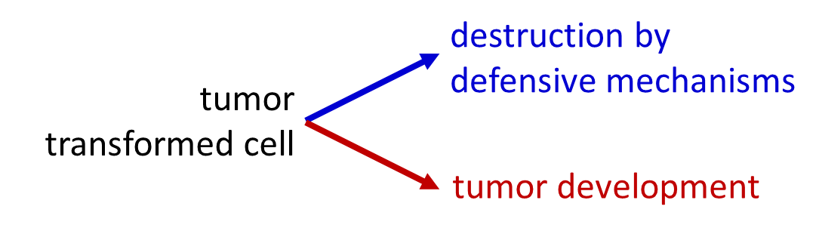
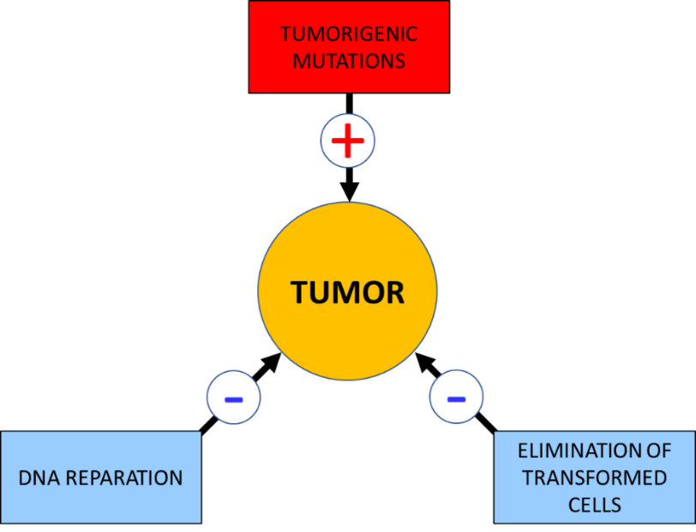

Protoonkogenes
- growth factors
- growth factor receptors
- intracellular signal pathway proteins
- transcription factors

Tumor suppressor genes, anti-oncogenes
- cell division inhibition
- differentiation promotion
- DNA reparation
- proapoptotic proteins

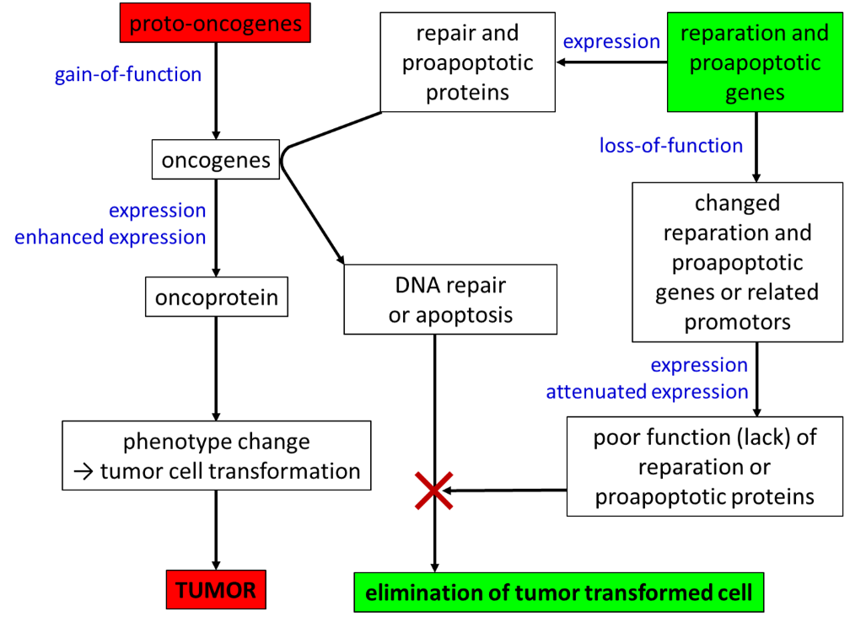

Mutation character
- mutation (usually more mutations in one cell are necessary) of proto-oncogenes, tumor suppressor genes
In the case of recessive mutations, change of both alleles is necessary.

- mutation in protein structure-encoding DNA sequence or change of gene expression control

- point mutations
- sequence insertion
- gene amplification
- translocation
- etc.

Philadelphia chromosome
= translocation of terminal parts of long arms of chromosomes 9 and 22
→ abl and bcr fusion → bcr-abl
→ protein having enhanced tyrosine-kinase activity
→ chronic myeloid leukemia

Genetic instability of tumors
In the frame of tumor transformation, defective DNA repair and defective induction of apoptosis in the case of irreparable mutation develop.
→ higher probability of accumulation of other mutations
→ malignisation of a benign tumor
→ creation of secondary cell clones in the tumor
→ tumor cell population heterogeneity

p53- mutation in 50 - 60% of human malignant tumors
Non-functioning p53 = selection advantage for a tumor cell

Defense against the tumor and its creation
- tumor suppressor genes
- immune system - namely NK-cells, Tc-lymphocytes

Precancer (precancerosis)
= pathological change of the tissue close to a cancer or preceding cancer development
Example: Barrett‘s esophagus
= intestinal metaplasia of the esophageal mucous membrane
(squamous epithelium → cylindrical epithelium)
- a consequence of the gastroesophageal reflux → irritation, inflammation

Etiologic and risk factors
factors that increase probability of mutations + factors reducing efficiency of defensive mechanisms
- radiation
- chemical carcinogens, including free radicals
- biological factors - viruses, etc.
- states connected with intensive cell proliferation
- heredity
- immunodeficiency
- ↓ protective factors (tissue quality, antioxidants, dietary fiber...)
Most of these factors are present permanently in some levels
Intensity + time of exposure + factor combination + individual sensitivity

Radiation
UV, RTG, α, β, γ
- DNA damage = mutations
- tissue damage = ↑proliferation

Chemical cancerogens
- interaction with DNA
- oxidative injury
- tissue irritation

- food
- water
- air pollutants
- medicaments (e.g. cytostatic)
- smoking
→ determination of the most frequent tumor lacalizations

Precancerogenes = converted by metabolism to cancerogenes

Protective substances: antioxidants, dietary fiber, some vitamines

Viral etiology of tumors
- insertion of viral DNA into the cell genome (RNA viruses - reverse transcription)
= direct mutagenic effect
→ oncogene insertion
→ active promotor insertion in front of a proto-oncogene
→ damage of a tumor suppressor gene

Indirect effects:
e.g. HIV (immune deficiency), hepatitis B (damage and abnormal reparation of the tuissue)

Other microorganisms
- tissue irritation (Helicobacter pylori)
- production of cancerogenic substances (molds)

States of intensive cell proliferation
- Chronic irritation, tissue damage, inflammation, (gastroesophageal reflux, liver cirhosis...)
- Hormonal stimulation

Heredity of tumors
- Disposition for tumors in general or for a particular tumor type
- An inherited mutation → in all cells → ↑ probability, that in one of them other mutations necessary to complete tumor transformation appear by chance, or mutation of the second allele
- An inherited mutation can lead to genome instability and increased sensitivity to mutagenic factors or reduced immune system capacity

Retinoblastoma
- mutation of the Rb suppressor gene
- AD heredity
- loss of heterozygosity

Li-Fraumeni syndrome
- p53-encoding gene mutation
→ disposition for tumors in an early age

Neurofibromatosis
- NF1 gene mutation (morbus von Recklinghausen, peripheral type of neurofibromatosis) or NF2 gene mutation (central type)

Familiar adenomatous polyposis of the large intestine

Lynch syndrome – colorectal cancer

Tumor stroma and vascular bed
- fibroblasts, vessels, extracellular matrix = tumor niche
- production of angiogenic growth factors VEGF, FGF, impact on metastatic process, increase of resistance of tumors to cytostatic treatment
- Vessels in the tumor are often abnormal – irregular lumen, higher vessel wall permeability.

The impact of tumors on the organism
- infiltration and destruction of the organ, replacement of the functioning tissue with the tumor
- bone destruction + Ca release
- organ compression (e.g. intracranial hypertension) → functional deficits, organ damage
- lumen obstruction
- cachexia
- chronic bleeding into the GIT, urinary tract → anemia
- hormone production
- production of pathological protein - myeloma → paraprotein
- pain ← compression, occlusion, tissue damage, bone fractures

Paraneoplastic syndromes
= tumor manifestations, that are not caused by growth of the primary tumor or its metastases directly in the organ
→ change of functions of organs in that the tumor is not localized
- Production of hormones by tumor originating from non-endocrine tissues
- e.g. small-cell lung cancer → ACTH, PTHrP
- Changed cytokine production
- Changed immune system function
- Synthesis of proteins similar to sequestered antigens (CNS!) → autoimmunity → paraneoplastic encephalomyelitis, ataxias...
- Suppression of erythropoietin secretion, vit. B₁₂ and folic acid consumption → anemia
- Penetrance of tumor cells into the circulation, tissue factor expression → DIC
- Cachexia

Tumor markers
= substances present in the organism as a consequence of a malignant tumor
- released parts or secrets of tumor cells
→ detectable in the blood → diagnosis, therapy evaluation

Alfa-fetoprotein (AFP)
- liver cancer
- but also in the liver cirrhosis

Carcinoembryonic antigen (CEA)
- adenocarcinomas, namely colorectal c.
- but also inflammations

Prostatic specific antigen (PSA)
- prostate cancer

